Projects under version control

In the previous lesson, we linked RStudio with Git and GitHub. In doing this, we created a repository on GitHub and linked it to RStudio. Sometimes, however, you may already have an R Project that isn’t yet under version control or linked with GitHub. Let’s fix that!

Linking an existing Project with Git

So what if you already have an R Project that you’ve been working on, but don’t have it linked up to any version control software (tut tut!)?

Thankfully, RStudio and GitHub recognize this can happen and have steps in place to help you (admittedly, this is slightly more troublesome to do than just creating a repository on GitHub and linking it with RStudio before starting the project…).

So first, let’s set up a situation where we have a local project that isn’t under version control. Go to File > New Project > New Directory > New Project and name your project. Since we are trying to emulate a time where you have a project not currently under version control, do **NOT** click “Create a git repository”. Click Create Project.

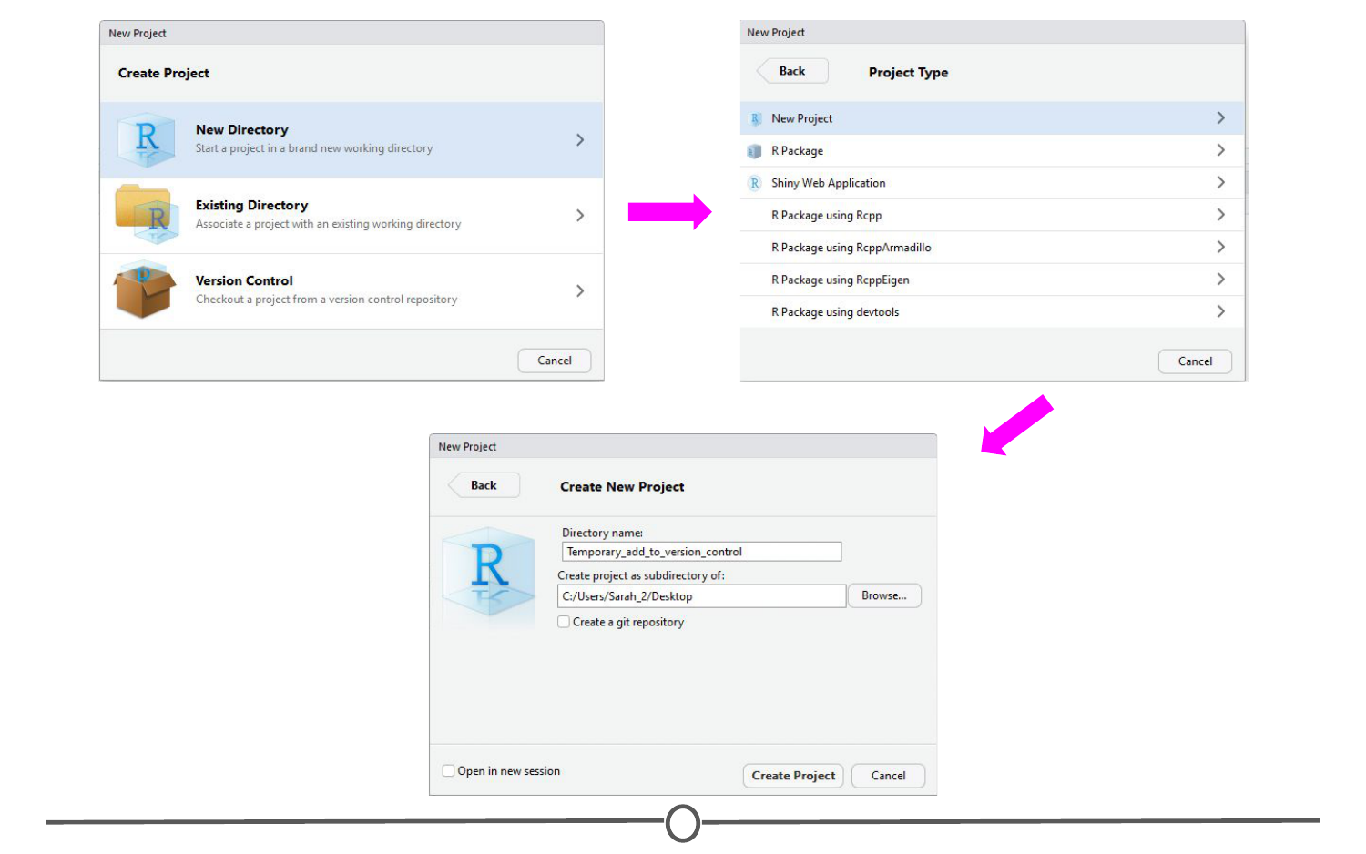

**Creating a project that is not under version control**

We’ve now created an R Project that is not currently under version control. Let’s fix that. First, let’s set it up to interact with Git. Open Git Bash or Terminal and navigate to the directory containing your project files. Move around directories by typing cd ~/dir/name/of/path/to/file

When the command prompt in the line before the dollar sign says the correct directory location of your project, you are in the correct location. Once here, type git init followed by git add . - this initializes (*init*) this directory as a git repository and *adds* all of the files in the directory (.) to your local repository. Commit these changes to the git repository using git commit -m "Initial commit"